Eigenvalues – Eigenvector
- When you apply a matrix transformation to a vector (by multiplying the matrix by the vector), the result is typically a new vector pointing in a different direction. However, if that vector is an eigenvector, the matrix transformation only scales that vector (it may stretch or shrink it), but it doesn't change its direction.
- The eigenvalue is the amount by which the vector is scaled
- Eigenvalues are scalars that show how much the transformation (like rotation, scaling, or stretching) changes the magnitude of a vector.
- If 𝐴 is a matrix and 𝑣 is an eigenvector of 𝐴, then: $Av=λv$
Where:
$λ$ is the eigenvalue, which indicates how much the eigenvector 𝑣 is stretched or shrunk during the transformation.
- Eigenvectors are special directions in space that remain unchanged in direction after applying a linear transformation (like rotation, scaling, etc.).
- Eigenvalues are the amounts by which the eigenvectors are stretched or shrunk during this transformation.
- In machine learning, eigenvalues represent the importance of each principal component in the data when performing Principal Component Analysis (PCA). Larger eigenvalues indicate that the corresponding principal component explains more variance in the data.

Consider the matrix $A$:
$$A= \left(\begin{matrix}4 & 1 \\ 2 & 3\end{matrix}\right)$$
To find the eigenvalues and eigenvectors of this matrix:
Find the eigenvalues: The eigenvalues 𝜆 are found by solving the characteristic equation:
$$\det\left(A-λI\right)=0$$
Where $I$ is the identity matrix, so the equation becomes
$$det\left[\begin{matrix}4-λ & 1 \\ 2 & 3-λ\end{matrix}\right]=0$$
The determinant of this matrix is:
$$\left(4-λ\right)\left(3-λ\right)-2=0$$
Expanding this:
$$λ^{2}-7λ+10=0$$
$λ_{1}=5$ and $λ_{2}=2$
Find the eigenvectors: For each eigenvalue, substitute 𝜆 into the equation $(A-λI)v=0$, and solve for the eigenvector 𝑣.
For $λ_{1}=5$: solve $(A-5I)v=0$:
$$\left[\begin{matrix}-1 & 1 \\ 2 & -2\end{matrix}\right]\left[\begin{matrix}v_{1} \\ v_{2}\end{matrix}\right]=0$$
This gives the eigenvector $v_{1}=\left[1,1\right]$
For $λ_{2}=2$: solve $(A-2I)v=0$:
$$\left[\begin{matrix}2 & 1 \\ 2 & 1\end{matrix}\right]\left[\begin{matrix}v_{1} \\ v_{2}\end{matrix}\right]=0$$
This gives the eigenvector $v_{1}=\left[-1,2\right]$
Eigenvectors are the directions that remain unchanged in direction, but they may get stretched or shrunk by the transformation.

What is Principal Component Analysis (PCA)?
Principal Component Analysis (PCA) is a dimensionality reduction technique widely used in statistics, machine learning, and data analysis. Its goal is to reduce the number of variables (or features) in a dataset while retaining as much information (variance) as possible. It does so by transforming the data into a new set of variables, known as principal components (PCs), which are linear combinations of the original variables.
Why is PCA Used?
- PCA is used in various scenarios, such as:
- Reducing the dimensionality of large datasets (e.g., when you have many features).
- Noise reduction: By keeping only the principal components that account for the most variance, you can reduce noise.
- Visualization: Reducing high-dimensional data to 2 or 3 components makes it easier to visualize.
- Speeding up algorithms: By reducing the number of features, PCA can improve the computational efficiency of machine learning models.
Steps of PCA:
Standardize the Data:
PCA works by analyzing the covariance matrix of the data. To make sure all features contribute equally (since they may have different units or scales), you should first standardize the data (subtract the mean and divide by the standard deviation for each feature).

Compute the Covariance Matrix:
This matrix shows how the features in the dataset vary with respect to each other.

$$Cov(X,Y)=\frac{1}{n-1}\sum{\left(X_{i}-\overline{X}\right)} \left(Y_{i}-\overline{Y}\right)$$
Where 𝑋 and 𝑌 are two features, and $\overline{X}$ and $\overline{Y}$ are their respective means.
Calculate Eigenvalues and Eigenvectors:
The next step is to calculate the eigenvalues and eigenvectors of the covariance matrix.
- The eigenvectors represent the directions of maximum variance (principal components).
- The eigenvalues indicate the magnitude of the variance along those directions.
Sort Eigenvectors by Eigenvalues:
The eigenvectors are sorted in decreasing order of their eigenvalues, i.e., the principal components that explain the most variance come first.
Choose the Top $k$ Principal Components:
Based on the eigenvalues, select the top 𝑘 eigenvectors (or principal components) that explain the most variance in the data.
Transform the Data:
Finally, project the original data onto the new set of principal components to reduce the dimensions. The result is the transformed dataset with fewer dimensions but still retaining most of the original variance.

Example:
Consider the following 2D dataset:
Sample | $$x_{1}$$ | $$x_{2}$$
1 | 2 | 3
2 | 3 | 4
3 | 4 | 5
4 | 5 | 6

Standardize the Data:
First, we need to standardize the data (subtract the mean and divide by the standard deviation). Let's calculate the mean and standard deviation for each feature:
Mean of $x_{1}=\left(2+3+4+5\right)/4=3.5$
Mean of $x_{2}=\left(3+4+5+6\right)/4=4.5$
​ Now, we subtract the mean and divide by the standard deviation (for simplicity, we will assume the standard deviations are 1 for this example):
$$\acute{x_{1}}=\frac{x_{1}-mean(x_{1})}{std(x_{1})}=\frac{x_{1}-3.5}{1}$$
$$\acute{x_{2}}=\frac{x_{2}-mean(x_{2})}{std(x_{2})}=\frac{x_{2}-4.5}{1}$$
Sample | $$\acute{x_{1}}$$ | $$\acute{x_{2}}$$
1 | -1.5 | -1.5
2 | -0.5 | -0.5
3 | 0.5 | 0.5
4 | 1.5 | 1.5

Compute the Covariance Matrix:
This matrix shows how the features in the dataset vary with respect to each other.

$$Cov(\acute{x_{1}},\acute{x_{2}})=\frac{1}{n-1}\sum{\left(\acute{x_{1i}}-\overline{\acute{x_{1}}}\right)} \left(\acute{x_{2i}}-\overline{\acute{x_{2}}}\right)$$
For simplicity, the covariance matrix for our example is:
$$Cov\left(X\right)=\left[\begin{matrix}1 & 1 \\ 1 & 1\end{matrix}\right]$$
This indicates that the features $\acute{x_{1}}$and $\acute{x_{2}}$ are perfectly correlated.
Calculate Eigenvalues and Eigenvectors:
Now we compute the eigenvalues and eigenvectors of the covariance matrix. For our covariance matrix:
$$Cov\left(X\right)=\left[\begin{matrix}1 & 1 \\ 1 & 1\end{matrix}\right]$$
The eigenvalues $λ$ can be found by solving the characteristic equation:
$$det\left(Cov\left(x\right)- λI\right)=0$$
This gives us the eigenvalues:
$λ_{1}=2$ and $λ_{2}=0$
The eigenvectors corresponding to these eigenvalues are:
$v_{1}=\left[1,1\right]$ for $λ_{1}=2$
$v_{2}=\left[-1,1\right]$ for $λ_{2}=0$
Choose the Principal Components:
Since $λ_{1}=2$ is larger than $λ_{2}=0$, we choose the eigenvector $v_{1}=\left[1,1\right]$ as the first principal component. This represents the direction that captures the most variance in the data.
Project the Data onto the Principal Component:
Finally, we project the standardized data onto the first principal component $v_{1}=\left[1,1\right]$.
For each sample, we calculate the projection as the dot product of the standardized data and the eigenvector:
Projection = $\acute{x_{1}}.1+\acute{x_{2}.1}$
For each sample:
- Sample 1: $\left(-1.5\right).1+\left(-1.5\right).1=-3$
- Sample 2: $\left(-0.5\right).1+\left(-0.5\right).1=-1$
- Sample 3: $\left(0.5\right).1+\left(0.5\right).1=1$
- Sample 4: $\left(1.5\right).1+\left(1.5\right).1=3$
The new transformed dataset is:
Sample | Projected value (First Principal Component
1 | -3
2 | -1
3 | 1
4 | 3

Conclusion:
- The principal component captures the most important direction (variance) in the data.
- By projecting the data onto this principal component, we've reduced the data from 2 dimensions to 1 dimension while retaining the most important information.

Example 02
Dataset:
Consider the following 3-dimensional dataset with 5 samples (rows) and 3 features (columns):
Sample | $$x_{1}$$ | $$x_{2}$$ | $$x_{3}$$
1 | 2 | 3 | 5
2 | 3 | 4 | 6
3 | 4 | 5 | 7
4 | 5 | 6 | 8
5 | 6 | 7 | 9

We want to reduce this 3D dataset to 2D using PCA, which means we will find the two most important directions (principal components) that capture the most variance in the data.
Step-by-Step PCA:
Standardize the Data:
First, we standardize the dataset by subtracting the mean of each feature and dividing by the standard deviation. Let’s calculate the mean and standard deviation for each column:
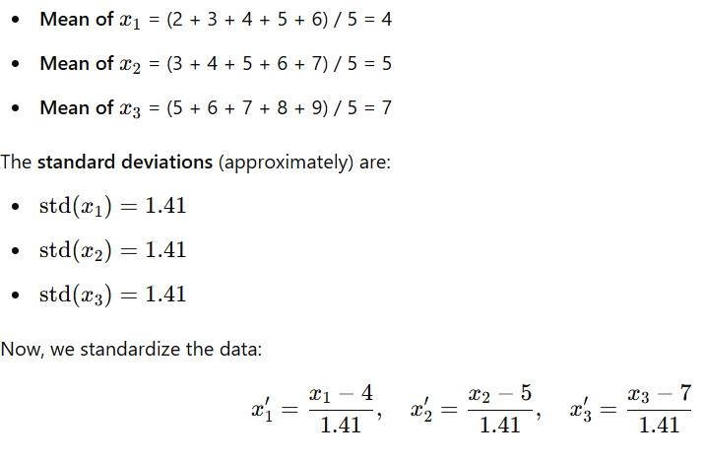
The standardized data is:

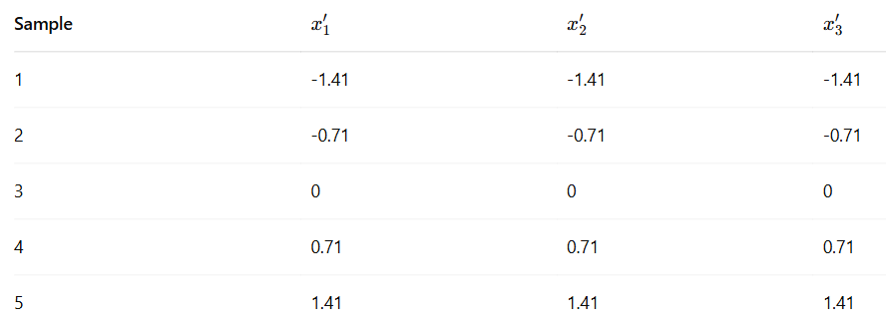
Compute the Covariance Matrix:
Next, we calculate the covariance matrix of the standardized data. This matrix captures the relationships between the features (i.e., how much each pair of features varies together).

For this 3D dataset, the covariance matrix is:
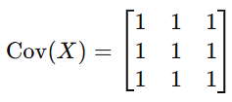
This covariance matrix suggests that all features are perfectly correlated.
Calculate Eigenvalues and Eigenvectors
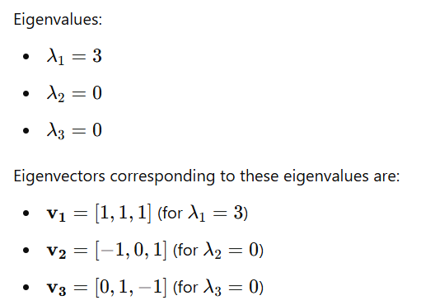

Choose the Principal Components
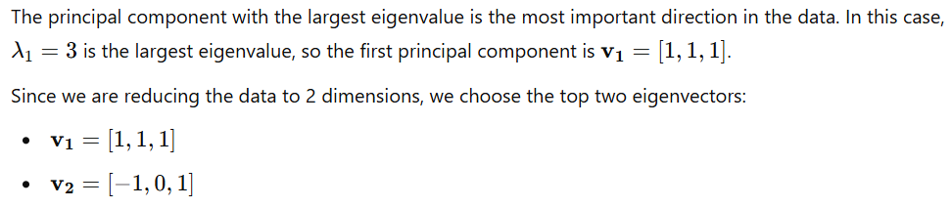
Project the Data onto the Principal Components
Now, we project the standardized data onto the first two principal components. This involves taking the dot product of the standardized data with the eigenvectors.
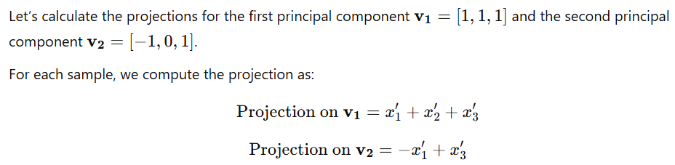
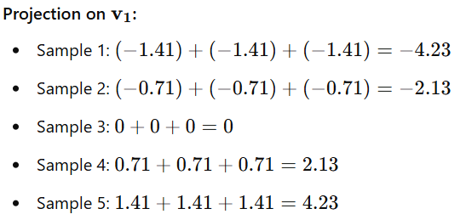
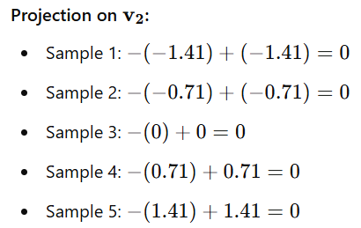

New Transformed Dataset
The new 2D dataset (after PCA) can now be represented as:
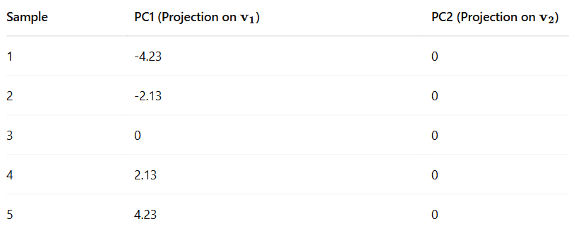
Conclusion:
- We successfully reduced the data from 3 dimensions to 2 dimensions.
- The first principal component (PC1) captures the most variance, and the second principal component (PC2) is trivial (it has no variance in this case).
- In practice, we would ignore PC2 (which has 0 variance) and use only PC1 for dimensionality reduction, meaning we have reduced our dataset from 3D to 1D.

Example 03
Dataset:
Consider the following 4-dimensional dataset with 6 samples (rows) and 4 features (columns):

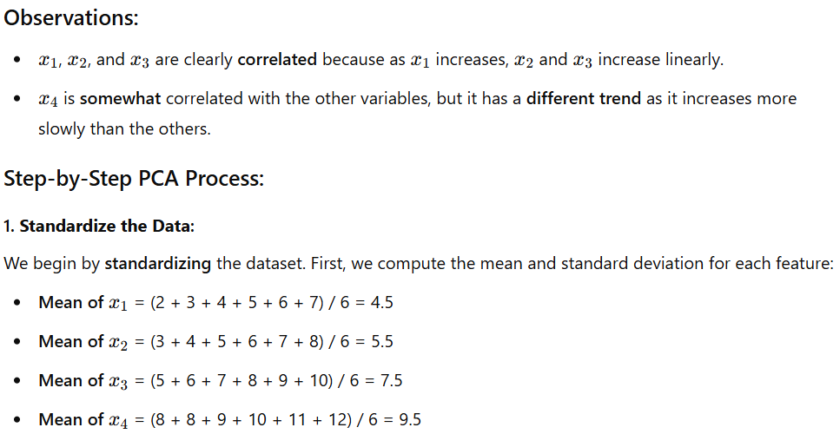
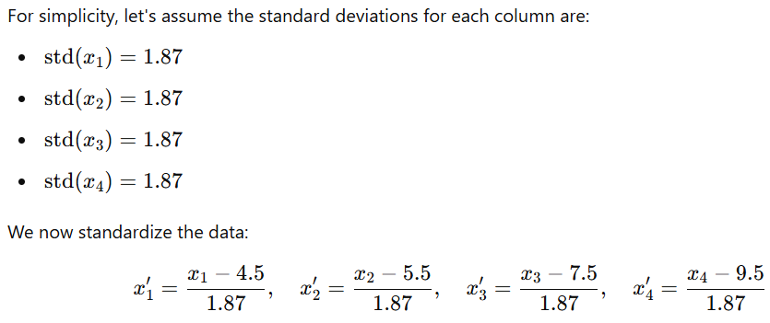
After standardizing, the dataset looks like this:
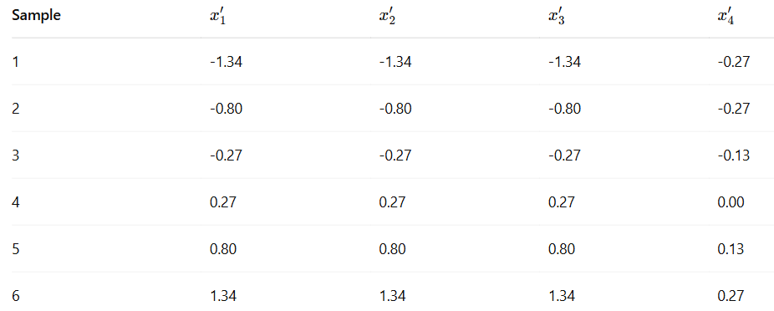
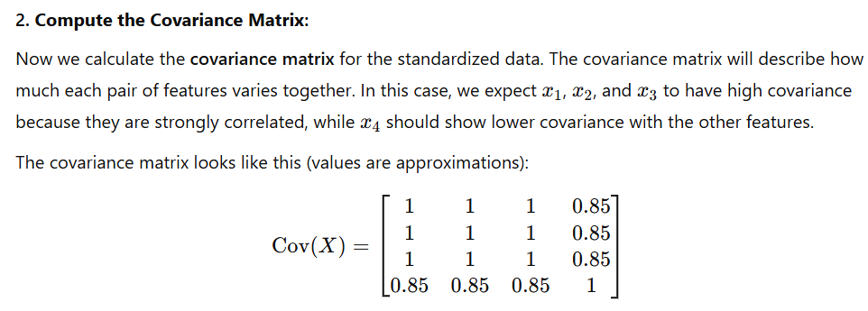
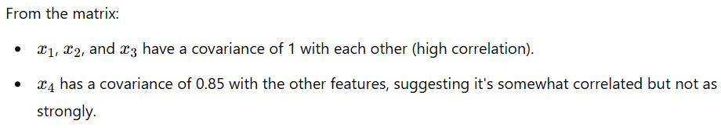
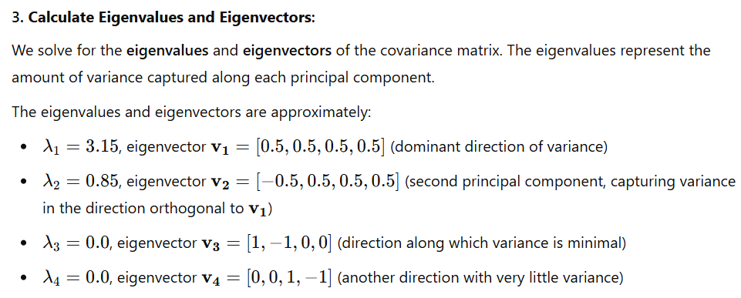
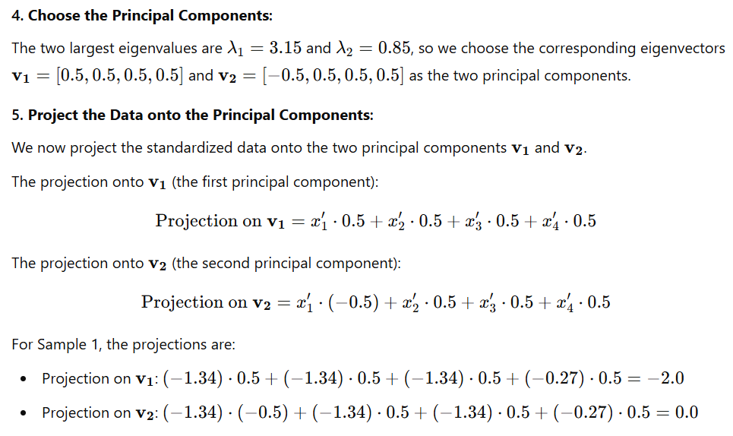
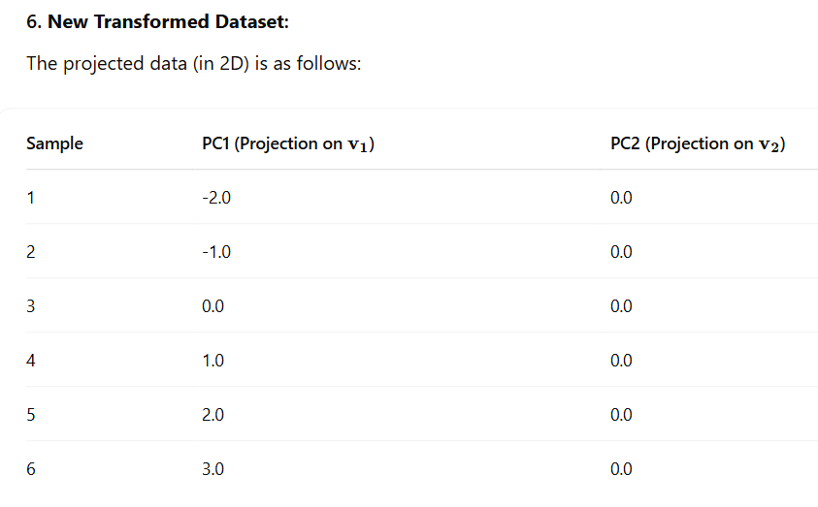
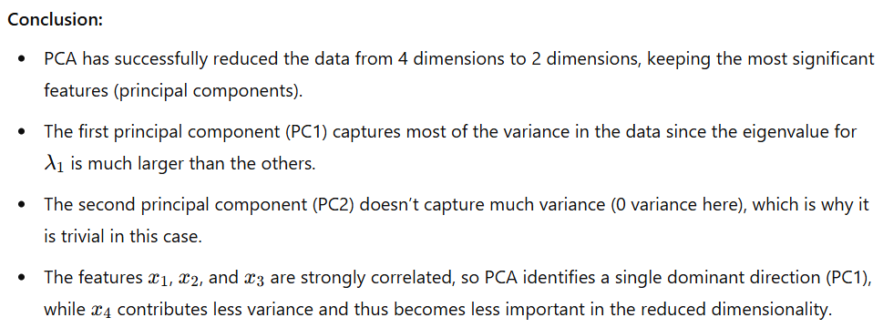

The equation $Av=λv$ provides key insights into the behavior of linear transformations represented by the matrix 𝐴. Here are the insights gained from this equation:
- Understanding Directional Invariance
- Eigenvectors 𝑣 reveal directions in which the matrix transformation 𝐴acts in a very specific way: these vectors do not change their direction after the transformation. They may be stretched or shrunk, but they remain aligned with their original direction.
- This property is very important because, in many real-world problems, we often want to know which directions (or axes) in a dataset are significant, particularly when the data exhibits complex relationships.
- Principal Directions in Data
In data analysis and machine learning (e.g., PCA), the eigenvectors point to the principal directions of variance in the data. These directions are the ones that capture the most significant features of the data.
- Eigenvectors identify the axes in a multidimensional space that explain the most variance in the data.
- Eigenvalues quantify the importance of each principal component (eigenvector). The larger the eigenvalue, the more variance that component captures.
- Impact of Correlation
- The existence of eigenvectors and eigenvalues also helps in understanding the correlation between features. Features that are highly correlated tend to have eigenvectors that point in the same direction, and their eigenvalues will be larger.
- If there is little correlation between features, the eigenvectors will point in different directions and the eigenvalues will be more spread out.
- Dimension Reduction:
In cases like Principal Component Analysis (PCA), the eigenvectors associated with the largest eigenvalues represent the most significant directions in the data. These can be used to reduce the dimensionality of the data while retaining most of its variance.
- This means we can compress the data by projecting it onto the subspace spanned by the most important eigenvectors (those with the highest eigenvalues).
Summary of Insights:
- Eigenvectors represent directions in space that remain unchanged in orientation under a matrix transformation, and eigenvalues represent the scaling factor along those directions.
- Eigenvectors and eigenvalues are fundamental in simplifying complex matrix operations, particularly in the context of dimensionality reduction, system stability, and understanding the intrinsic properties of data or physical systems.
- In machine learning, they help reduce dimensions in datasets by identifying principal components that capture the most important variance in the data.

Understanding Directional Invariance in the Context of Eigenvectors and Eigenvalues:
Directional invariance refers to the property of an object or system that preserves its direction under some transformation. In the context of linear algebra, eigenvectors represent directions that remain unchanged (in terms of orientation) when a linear transformation is applied to them, but they may experience scaling (stretching or shrinking).

The Concept of Directional Invariance:
The key point here is that eigenvectors maintain their direction under the matrix transformation. This means that:
- The orientation (the angle relative to other vectors or axes) of the eigenvector does not change.
- However, the length (magnitude) of the eigenvector might change by a factor of 𝜆, which is the corresponding eigenvalue.
This property is called directional invariance. It tells us that the transformation affects only the size (scaling) of the vector along the direction of the eigenvector, but not the direction itself.

Principal Component Analysis (PCA):
In PCA, eigenvectors represent the directions in the data where the variance is maximized. These directions are the ones where the data shows the most spread. These eigenvectors (also known as principal components) are directionally invariant, meaning they don’t change direction, but the data can be projected onto them to reduce dimensionality.

Directional Invariance in PCA
In Principal Component Analysis (PCA), the goal is to reduce the dimensionality of the data while retaining as much of its variability (variance) as possible. Eigenvectors, also called principal components in PCA, represent the directions along which the data varies the most.

The key idea is that these eigenvectors (principal components) are directionally invariant. This means that once we identify the principal components (eigenvectors), we can project the data onto these directions. The projection doesn't change the direction of the eigenvectors; it just tells us how much the data varies along each of these directions.

Key Concepts in PCA:
Variance and Direction:
- Variance is a measure of how spread out the data is along a particular dimension.
- Principal components (eigenvectors) are the directions in which the data shows the most spread (variance).
- By identifying these directions, we can reduce the dimensionality of the data while still retaining the most important features of the original data.
Eigenvectors and Eigenvalues in PCA:
- The eigenvectors represent the directions where the data exhibits the most variance. These are the directions of maximum spread in the dataset.
- The eigenvalues associated with these eigenvectors represent the amount of variance in the data along these directions.
For example, an eigenvalue of 10 means that the data varies by 10 units along the corresponding eigenvector direction.
Directional Invariance in PCA:
- In PCA, eigenvectors are directionally invariant: Once the principal components are found, projecting data onto them will not alter the direction of the components. Instead, it will simply tell us how far along each principal component the data is spread.
- The key point is that these directions do not change — they are stable, and we can compress the data by keeping only the most important principal components.
Dimensionality Reduction:
By projecting data onto the principal components, we can reduce its dimensionality: we keep only the most important directions (those with the largest eigenvalues) and discard the others, effectively simplifying the data while preserving the most critical information.

Assessing and Evaluating Data Reduction Using Eigenvectors (PCA)
In Principal Component Analysis (PCA), data reduction is achieved by projecting the original data onto a smaller set of principal components (eigenvectors) that capture the most variance. The goal is to retain as much of the important information (variance) as possible while reducing the number of dimensions in the data. To evaluate the effectiveness of this data reduction, you can assess and evaluate it through the following methods:
- Explained Variance Ratio
- Scree Plot
- Cumulative Explained Variance Plot
- Data Reconstruction Error
- Visual Inspection (for 2D/3D Data)
- Comparing Model Performance Before and After PCA

